**Description of the resource**: CCT related Drosophila lines and plasmids generated by Dr. Yi Rao’s Lab at Peking University (Deng et al., 2019).

**We hope the CCT Drosophila resource could benefit all the fly community, and if you find any problem related to the resource, please let us know through** [**dengbowen@nibs.ac.cn**](mailto:dengbowen@nibs.ac.cn) **or** [**yrao@pku.edu.cn**](mailto:yrao@pku.edu.cn)**. We will keep all the information updated on our website (http://raolab.org/more.php?cid=84)**

**Method to generate the Drosophila lines:**

1, Knock out line generation:

All the attP lines (attP-3P3RFP as insertion element) were generated through method described in Deng et al., 2019. In general, a genomic region was replaced by attP-3P3RFP through homologous recombination, and the 20bp genomic sequence after 5’ARM and 20bp genomic sequence before 3’ARM were list in Table S2. The design details of each gene could also be found in .gb files which including gene structure, gRNA information and homologous arm sequences.

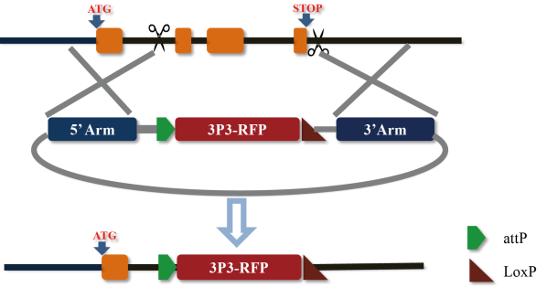

**Note**: some of the attP lines might have multiple attP-3P3RFP with the target region replaced by **tandem repeat attP-3P3RFP** just as showing below. But those lines could still be used as Knockout and tools for further engineering.

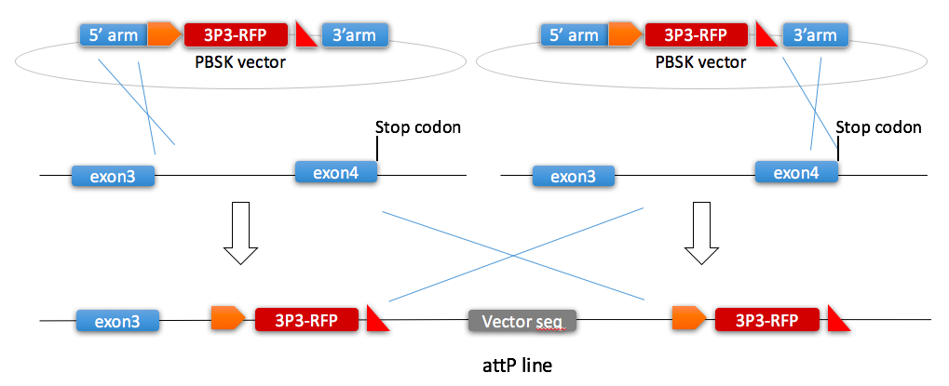

2, Knockin generation:

Most of the knockin lines were generated through attP/attB system based on the above attP lines, and all the selection markers were removed through Cre/LoxP system.

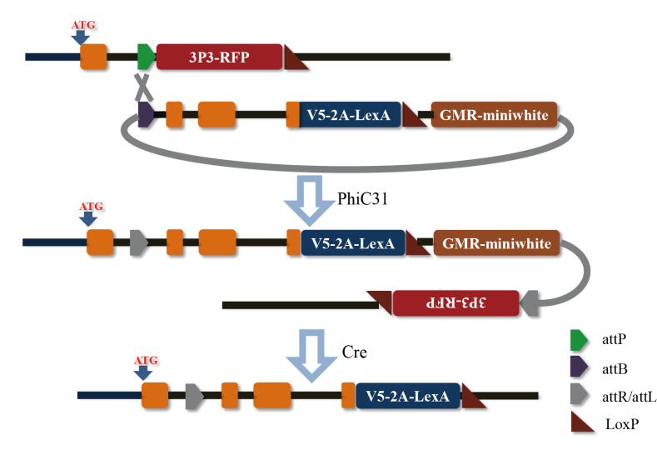

3, other related Drosophila lines:

Drosophila lines related to CCT which were generated through other strategies in Yi Rao’s Lab were also included in the Excel file.

Some of the knockin and knockout lines were generated through Ends-out strategy (Huang et al., 2009, Qian et al., 2017), and some lines were generated using Crispr/Cas9 to directly knockout or knockin the gene. **No gb files were provided for those lines.**

**Files for the resource:**

The ‘Deng et al. Fly Stock Information’ excel file included all the fly stocks in Yi Rao’s lab which could be delivered to other laboratories, and this file will be **weekly updated.**

The gb files included all the design details for the attP lines.

**Resource request:**

If you are interested in requesting our resource, please check our excel file at <http://raolab.org/more.php?cid=84> , and send an email to Yi Rao ([yrao@pku.ed](mailto:yrao@pku.edn)u) describing the materials you need.

**Reference:**

Deng, B., Li, Q., Liu X., Cao, Y., Li, B., Qian, Y., Xu, R., Mao, R., Zhou, E., Zhang, W., Huang, J., Rao, Y. (2019) Chemoconnectomics: mapping chemical transmission in Drosophila. Neuron 101, 876-893.

Qian, Y., Cao, Y., Deng, B., Yang, G., Li, J., Xu, R., Zhang, D., Huang, J., and Rao, Y. (2017). Sleep homeostasis regulated by 5HT2b receptor in a small subset of neurons in the dorsal fan-shaped body of Drosophila. eLife 6, e26519.

Huang, J., Zhou, W., Dong, W., Watson, A.M., and Hong, Y. (2009). From the cover: directed, efficient, and versatile modifications of the Drosophila genome by genomic engineering. Proc. Natl. Acad. Sci. USA 106, 8284–8289.